
American International University- Bangladesh (AIUB)
Faculty of Engineering (EEE)
Course Name: | COMPUTER AIDED DESIGN AND DRAFTING | Course Code: | BAE 2101
Semester: | Fall 2021-2022 | Sec: | Q
Faculty: | Raja Rashidul Hasan | Assignment No: | M1
Assignment Name: | Group Assignment
Submission Date: | 28-10-2021 (Thursday)
ID | Student Name | Department. | Serial No
20-42091-1 | ISLAM, MD. FORHADUL | CSE | 13
20-42356-1 | MALIYAT, NAFISA | CSE | 14

      - Design the following Circuits using AutoCAD 2007 Software from Experiment 5 as per : Total: 30 points
Group No | Experiment No | Figure No
Group: 1, 3, 14, 19 | Experiment 5 | Fig: 2 (a, b, c, d), Fig: 3 (a, b, c, d), Fig: 7
Group: 2, 4, 13, 16 | Experiment 5 | Fig: 1 (a, b, c, d), Fig: 3 (a, b, c, d), Fig: 4
Group: 5, 7, 15, 20 | Experiment 5 | Fig: 2 (a, b, c, d), Fig: 3 (a, b, c, d), Fig: 5
Group: 6, 8, 17, 11 | Experiment 5 | Fig: 1 (a, b, c, d), Fig: 3 (a, b, c, d), Fig: 7
Group: 9, 10, 12, 18 | Experiment 5 | Fig: 1 (a, b, c, d), Fig: 2 (a, b, c, d), Fig: 6

Submission Instructions:
- Do the assignment in a Group. Do not copy from others Group.
- Write your Name, ID & Serial no properly on the above Table
- Mansion all of your Serial No & Name including other information at top left corner of your design window as per INSTRUCTION in class
- Take Screen shot of your final design by indicating all dimensions properly. Hence, make a pdf by attach this top page.
- Submit pdf and all .dwg
- File Name : Group no_00_Assignment M1
- Submit your Assignment to: cadeeecse@gmail.com
- Subject of your Mail : CAD_Group no_00_Assignment M1_Fall 21-22

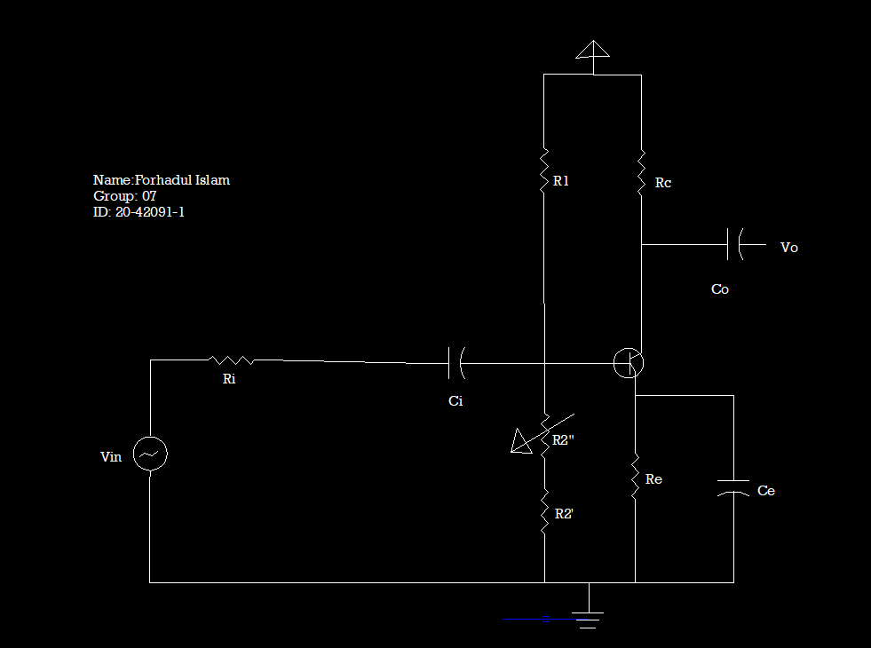
Figure : 2 (a)
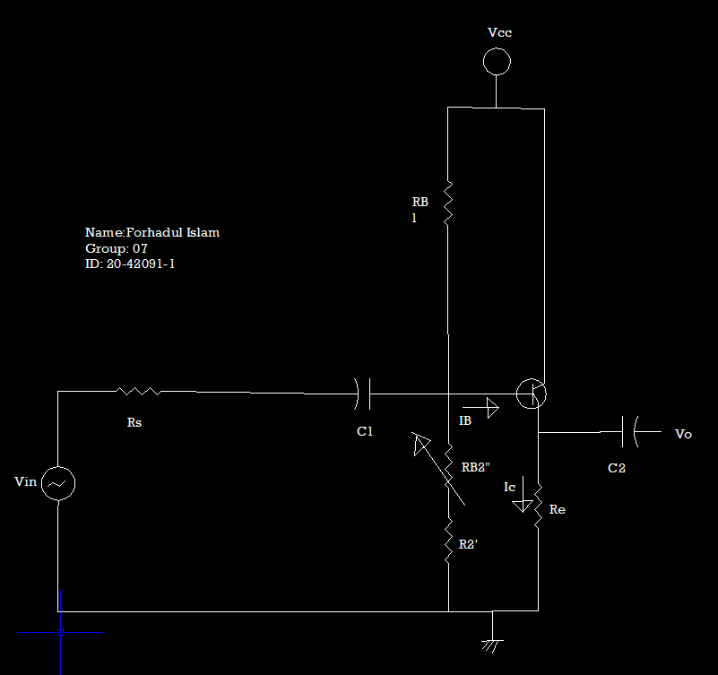
Figure : 2 (b)
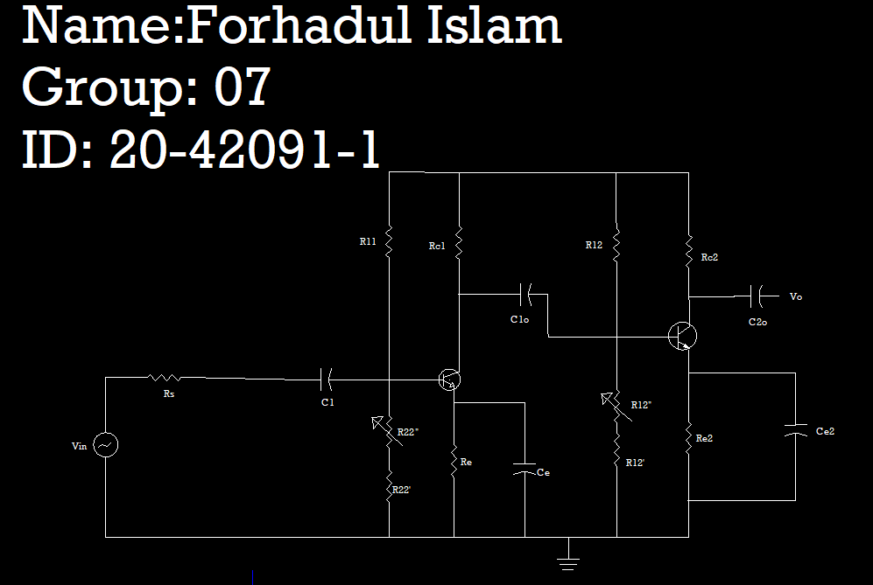
Figure :2 (c)
